**Supply Chain Logistics – Logistics Network**

**Review criteria less Please complete the following:**

1) Please describe the product you are planning to sell and why did you pick it?

2) Please upload an image file (.jpg or .png) of the warehouse network you created. Upload File?

3) Please describe your rationale why you picked the number of warehouses you did. Also, why did you pick the locations? Please be specific about each one.

4) What is the transit time to each customer? It would be best if you put the information in a table. What is the total transit time to all customers (add the individual transit times).

5) Please justify why your logistics network is the best you can make it for now and the foreseeable future. Be sure to talk about what the expectations of your customers will be; what the current economic environment looks like; and, where you expect interest rates and fuel prices to go in the future.

**EVALUATION**

**SUMMARY REPORT FEDEX TRANSPORTATION**

1) I am keen to sell Baby products, because India is a country has the highest sales in Baby products in the year of 2019. Baby product is not a seasonal product like winter wears in winter and shorts in summer. Baby product has always an advantage in it, someone has to die and someone has to born and there is no loss in it. India is the most populated country in the world other than China. The birth rate for India in 2018 and 2019 is 18.020 and 17.806 births per 1000 people. Most of the peoples move to the developed cities, for working purpose and becomes independent. Once the baby is born, they have an extra duty for baby. Due to the working pressure, they have no time to roam outside and buy Baby products for babies. So, they come to online platforms, where they get plenty of options to buy Baby products. In that I use the marketing techniques, like advertisement in YouTube. When they see any Baby maintaining videos, it will automatically projected in between the video. So I can able to get profit on selling Baby products.

2) 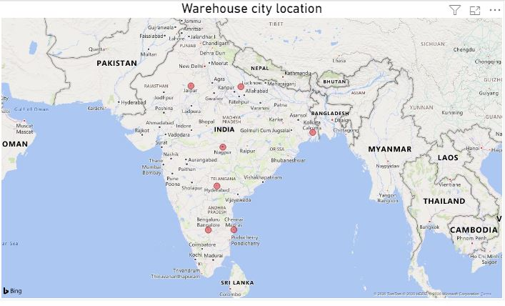

***Source: Power BI***

3) Import is done from Port of Houston, Texas to Jawaharlal Nehru Port, Mumbai. For the quick access I have kept warehouses in varies cities. From Mumbai it is very easy to transport varies Baby product to my Warehouse located cities through Railways. Railways is less expensive, it is fast and able to carry more load when compared to Roadways. The reason why I did not kept the warehouse in Mumbai is that, I will dispatch most products once the shipment arrives and few products are collected by the customers directly from the port. In India, sales of the Amazon are soaring in Southern part of India when compared to Northern part. For the easy ways of accessibility I have kept 3 warehouses in Southern part, 1 warehouse in north-east, 1 in north-west and other in eastern part of India. Last and important one is I kept 1 warehouse in Nagpur, which is situated in middle part of India. From Nagpur it is easy to dispatch any product across India. Nagpur warehouse plays an important role other than other warehouse. That’s why I selected these places.

4)

|  |  |  |  |
| --- | --- | --- | --- |
| **State** | **Warehouse city location** | **Location of the customer** | **Distance from the warehouse to the customers location** |
| Tamilnadu | Chennai | Madurai | 462 |
| Telangana | Hyderabad | Warangal | 145 |
| Uttar Pradesh | Lucknow | Agra | 336 |
| West Bengal | Kolkata | Howrah | 27 |
| Karnataka | Bengaluru | Mangalore | 352 |
| Maharashtra | Nagpur | Nasik | 669 |
| Rajasthan | Jaipur | Jodhpur | 417 |

5) Without the customers on business runs. So, I want to fulfil my customers wish, by delivering them on time with undamaged products. By mistake, if any items get damaged, it will be replaced within 1-2 days or refunded within 2-3 days. Replacement is done only with the help of warehouse & inventory provided. I will provide free shipping option over Rs 300.